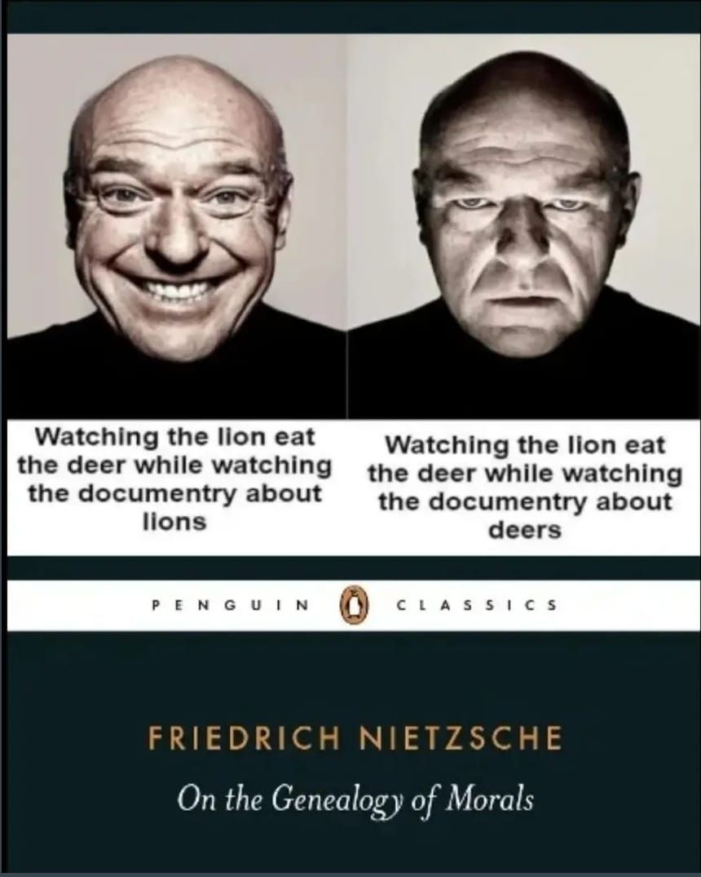

Was the great Philosopher Nietzsche a Behavioural scientist?

Here's a quote from him-

"If you crush a cockroach, you're a hero. If you crush a beautiful butterfly, you're a villain. Morals have aesthetic criteria"

There are many other animals and insects that are beautiful in the pure aesthetic sense too- but because they are pests, cancelling their subscription from life is easier.

This is, what we have formalised further, and have called "Framing bias/effect" in psychology and behavioural science.

This is just one example of many.

Our need to understand people and systems emerged the day civilization was born. Those whom we call legendary thinkers also happened to be great observers of human behaviour.

Frameworks may be modern, but the insights have always been there.

That is what I plan to do this year- Understanding the new from the lenses of the past.

